**EXHIBIT: DATABASE OF AMERICAN WINES**

*Prachi Shah, Kartik Adur, Luis Puga Vaglienti*

*ILS-Z 636 Semantic Web/Data Semantics*

*Project Report*

*2014*

**Abstract—the vision of the Semantic Web is an enhancement of the current web that involves an interplay between the web technologies and modern browsers to present interactive content. As such, this requires marrying the potential of semantic data with the best of the tools and technologies of the current web. This paper examines the use of semantic data pertaining to the domain of American wines and how the authors used Exhibit, an open-source tool to display the data dynamically online. The aim of this project was to demonstrate how semantic data can be merged with the tools of the current web to display data in different formats, and maintaining the semantics as well.**

Keywords: semantic web, semantic data, RDF, Exhibit, SIMILE, wine

**I. Introduction**

"The Semantic Web is not a separate Web but an extension of the current one, in which information is given well-defined meaning, better enabling computers and people to work in cooperation." [1] This definition offers a guidepost for this paper’s authors, who aspire to take the potential of semantic data and combine it with current web technologies to create a dynamic and user-friendly presentation of an RDF data set.

The advantage of semantic data is in “meaning,” as noted in the quote above. By creating a context for data, one can increase how such data is understood by both people and machine. This can create powerful new resources, which will empower new understandings and uses for the large data sets that are becoming characteristic of the era of so-called Big Data.

For this paper, the domain the authors chose to work with was wines, specifically those produced in the United States. Additionally, the authors wanted to create a a dynamic environment in which do display their data. To do so, the authors chose to use Exhibit, a MIT SIMILE widget, to present information about wines. This effort outlined in this paper, which will include sections on Approach, Tools and Technology, Implementation and Challenges, Work Roles, Conclusions and Future Work, and References.

**II. Approach**

The domain of wine offers a rich ontology to describe semantically. There are the variety of grapes, the vintages, the types of wine (Merlot versus Chardonnay), and the color. Much of this terminology is already agreed upon by producers and consumer of wine, making it ideal for the use in such a project.

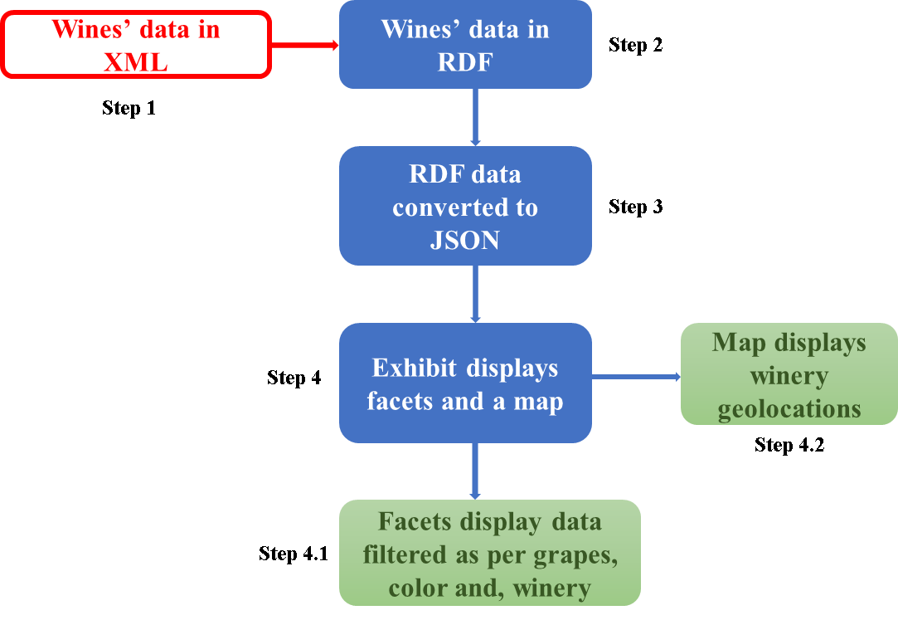

Figure : A process model of the Database of American Wines

Further, the relationship between the entities that would make up the data set are also well established. Wine is produced by vintners. It has color, alcohol content, and a year in which a particular bottle is produced. As such, the ontology of wine fits well into the triple format of an RDF graph, offering both functional and inverse functional relationships.

As a first step, the authors began by creating a dataset of wines in XML. At this juncture, the data was structured hierarchically, with the element of wines encompassing many sub elements such as color, vintage, etc. For the purposes of scope, the project was restricted to American wines, consisting of 9 wines and 5 wineries.

 Figure : a RDF diagram of the selection of American wines

This XML data set was then rendered into RDF data using the Web Ontology Language (OWL) standard. As shown in Figure 2, the elements of our data include color, graphs, wine, and wineries. Each of these elements includes instances of those elements. For example, color has instances such as “almost clear” or “green yellow. Grapes include instances of Syrah and Pinot Noir and wineries of specific vineyard in the United States. Additionally, there are data properties, such as alcohol content for wine, and longitude and latitude for wineries.

**III. Tools and Technology**

The next step was to select a method by which to display the data. For the purposes of this project, Exhibit, an open-source publishing framework, was selected.

Exhibit is a widget of the **S**emantic **I**nteroperability of **M**etadata and **I**nformation in un**L**ike **E**nvironments (SIMILE) Project started by the Massachusetts Institute of Technology. It has since become administrated by an open-source community. Exhibit offers users the ability to display data in an interactive format, making use of data from a wide variety of data files. By connecting this data to Exhibit, a user can format the data via HTML code and scripts that allow others to view, sort, and search the data. This includes facets that can sort one’s data into not only lists, but interactive timelines and maps. [2]

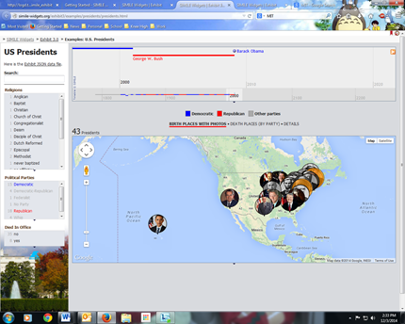

Figure 4: An example of an Exhibit project focused on U.S Presidents retrieved from http://simile.mit.edu/exhibit/examples/presidents/presidents-2.html

**IV. Implementation and Challenges**

For our project, the authors made use of Exhibit’s ability to parse RDF data formats. Exhibit accomplishes this by converting RDF into a JSON format, using a Babel converter. [3].

The authors also had to use of certain scripts in the HTML file. For example,

<script src="http://trunk.simile-widgets.org/exhibit/api/exhibit-api.js" type="text/javascript">

This line of script served as a reference to the Exhibit API. Additionally, the authors needed to indicate to Exhibit where our data file was located as well as indicate what type of data file it would be processing.

This proved to be somewhat difficult on the outset. The authors first encountered issues in which Exhibit would include unwanted data, such as property restrictions. At first, the authors were led to believe that it was an issue with the format of the RDF data. Upon further inspection, the authors discovered that it was using an older syntax used by a prior version of Exhibit. Once corrected, the data displayed correctly.

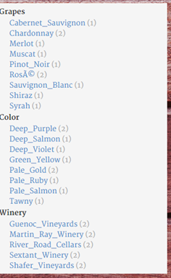 Figure : Facet filters wine data retrieved from http://ella.ils.indiana.edu/~kadur/Semantic%20Web/test1.html

Exhibit allowed us to organize the data into facets, which is displayed on a webpage hosted on the ella.ils.indiana.edu server of Indiana University, Bloomington. The hyperlink of the webpage is:

http://ella.ils.indiana.edu/~kadur/Semantic%20Web/dbAmericanWines.html.

For our purposes, the facets the authors chose displayed our data by Grapes, Color, and Winery. This was chosen with an end user in mind, either the wine consumer who would be interested in seeing all of the Pinot Noirs or wines of a certain color or winery, or the producer, interested in knowing the types of wine produced by competitors.

In addition to these facets, the authors also wanted to present other data views. The first was the default view a user would see upon viewing our page, which was a map that would dynamically change depending on the visitor manipulated the facets.

To create a map view, the authors included the following code as part of our HTML file:

<div ex:role="viewPanel" ex:initialView="0">

<div ex:role="view"

ex:viewClass="Map"

ex:label="Wines by Location"

ex:latlng=".producedBy.latlng"

ex:autoposition="true"

ex:maxAutoZoom="5"

ex:bubbleWidth="200"

ex:selectCoordinator="Wine">

The geolocation of the wineries was determined from the latitudes and longitudes included the RDF data. By default, the view would show the locations of all the wineries upon page load, with users able to dynamically change the data displayed using the page’s facets.

Exhibit’s map view also allows users to interact directly with the map’s graphic, selecting the vineyards that appear therein. This allows the user an alternative approach to the data that can display the different entities of the database in pop-up captions.

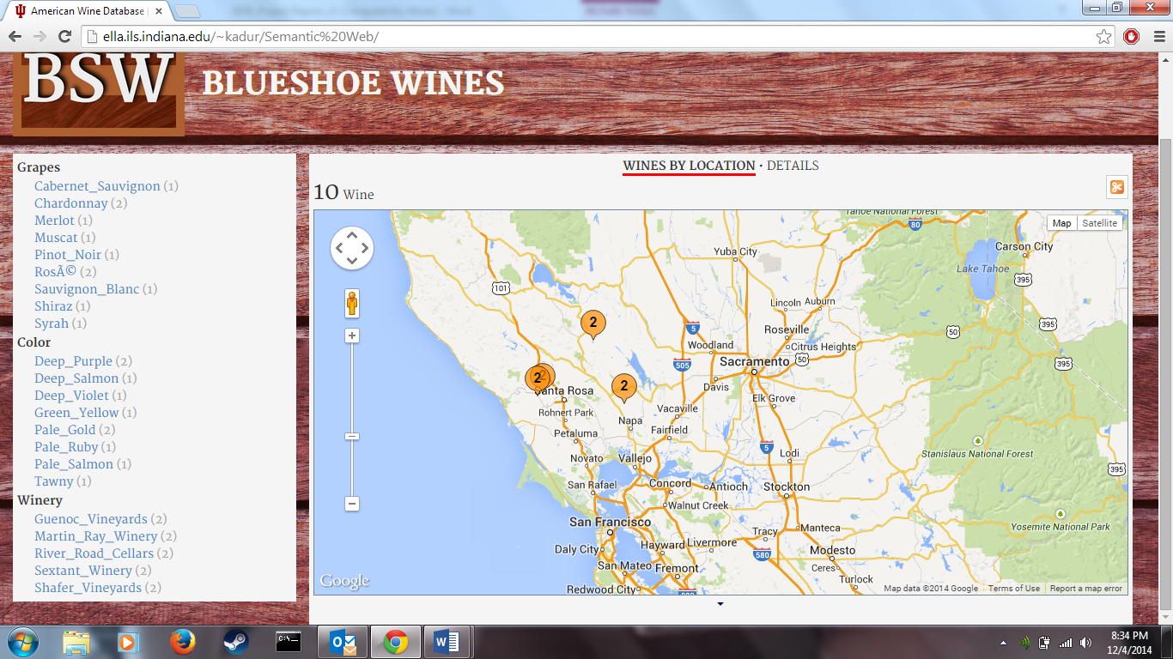

Figure 6: A map displays winery’ geolocations (latitude and longitude) retrieved from http://ella.ils.indiana.edu/~kadur/Semantic%20Web/test1.html

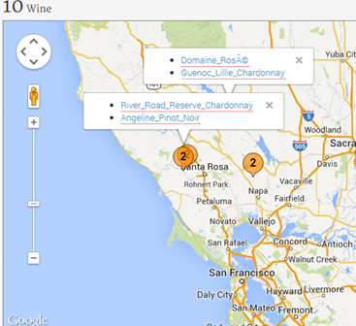

Figure : Figure 4: Geolocation of a winery that produces a wine of color ‘Deep purple’ retrieved from http://ella.ils.indiana.edu/~kadur/Semantic%20Web/test1.html

Additionally, the authors wanted to create a third data view, one which allowed users to view information about the wines and wineries in a tabular view. Again, Exhibit required some code that would allow for this functionality:

<div ex:role="view" ex:viewClass="Tabular" ex:label="Details"

ex:columns=".label,.producedBy,

.vintage,.hasColor,.madeFrom,

.alcoholContent"

ex:columnLabels="Name, Winery, Vintage, Color, Grapes, ABV"

ex:sortColumn="3"

ex:sortAscending="false"

ex:paginate="true"

ex:pageSize="5">

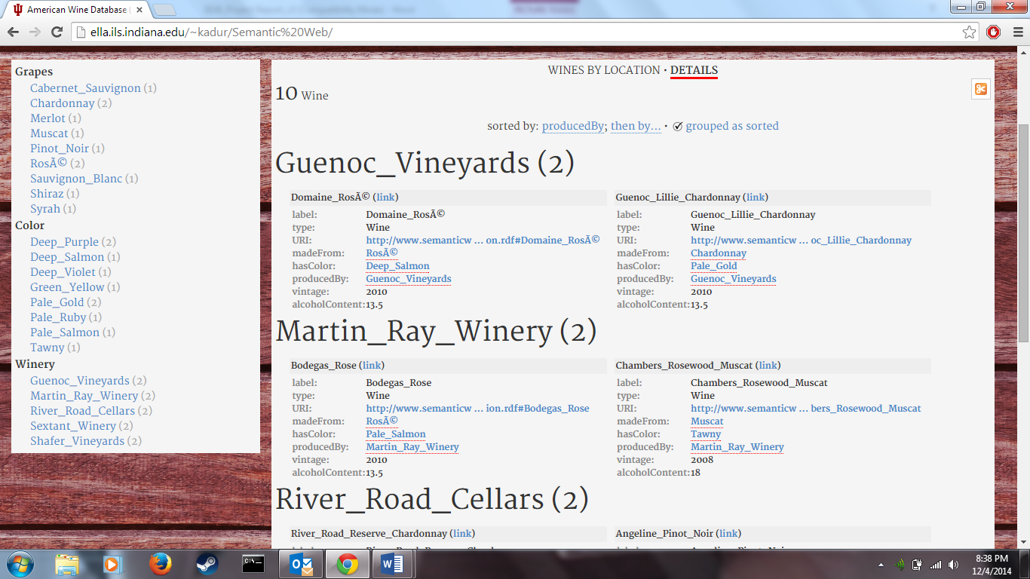

Figure 8: Complete wines’ information displayed in a tabular format retrieved from http://ella.ils.indiana.edu/~kadur/Semantic%20Web/test1.html

This data view can be found by selecting a link entitled “Details.” The faceted views of the data would remain if this view was selected, but the map would be replaced by tables.

In addition, the authors saw fit to add design element to the page. This was to enhance the user experience and seemed appropriate to the domain of wine. The design was influenced by other websites pertaining to wine, particularly those which represented wineries.

**V. Work Roles**

For our project, it was determined that the authors best worked together as a group. This was particularly helpful in helping each other as we encountered issues in understanding of the data, making use of Exhibit, and in drafting this paper. All the members contributed equally to the research, development, testing and documentation of the project.

**V. Conclusions and Further Work**

If the end goal of the Semantic Web is to enhance the current web, combining semantic data with such tools like Exhibit is a positive first step. Such work demonstrates how semantic data can become a powerful tool that is approachable to users. Tools such as Exhibit also demonstrate that, with relative ease, coders of all skill level can publish semantically Driven data from a variety of domains.

For this specific project, next steps could include expanding the data. There are many more American wines and certainly international wines that could be included in this database. Additionally, other data about wines could pose both an enhancement of the project and an interesting data challenge. This would pertain to the more subjective areas of the domain of wine, such as its taste or quality.

And of course, another function that should be explored is how this database could be connected to others. This could include connections to geographic/geological databases to show areas where certain grapes thrive or perhaps with a database of cuisine to allow users to choose the best wines for a specific meal. Such possibilities are achievable thanks to the nature of semantic data.

**VI. References**

1. Berners-Lee, T, Hendler, J, and Lassila, O. The Semantic Web, *Scientific American*. *284* (5), 34-43
2. Getting Started with Exhibit 3.0, 2012. Retrieved December 1, 2014: <http://www.simile-widgets.org/wiki/Getting_Started>.
3. Your Exhibit Data, 2012. Retrieved Dec 2, 2014 from http://simile-widgets.org/wiki/Data